Project Executable Files

Date | 28-09-2026
Team ID | SWTID-2026-1795
Project Name | ComicCraft - AI Comic Story Creator using Gemini Models
Maximum Marks | 3 Marks

Project Executable Files
This section requires submission of all executable and deployable files for your project. Ensure all files are properly organized, named, and uploaded to the specified submission platform. The evaluator must be able to run or deploy your solution using the provided files and instructions.

Step 1: Submission Checklist

S.No | Item to Submit | Submitted (Yes / No / NA)
1 | Complete source code (all files and folders) | Yes
2 | README / Setup Guide (instructions to run the project) | Yes
3 | requirements.txt / package.json / dependency file | Yes
4 | Database schema / seed files (if applicable) | Yes
5 | Environment configuration file (.env.example or similar) | Yes
6 | Deployed application URL (if hosted) | Yes
7 | APK / Executable binary (if applicable for mobile/desktop apps) | NA
8 | Dockerfile / Containerization config (if applicable) | NA
9 | Test files and test results | Yes
10 | Demo video or walkthrough (if required) | Yes

Step 2: File / Folder Structure
Provide an overview of your project's file and folder structure below:
ComicCraft/
├── app/
│ ├── ai/
│ ├── __init__.py
│ ├── config.py
│ ├── exporters.py
│ ├── layout_builder.py
│ ├── main.py
│ ├── routes.py
│ ├── schemas.py
│ └── services.py
├── static/
│ ├── css/
│ ├── panels/
│ └── exports/
├── templates/
├── tests/
│ ├── test_layout.py
│ └── test_routes.py
├── .env
├── .gitignore
├── LICENSE
├── README.md
├── requirements.txt
└── requirements-local-diffusers.txt
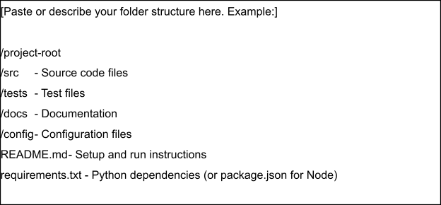

Step 3: Deployment / Access Details

Field | Details
Hosted / Deployed URL | • While running locally: http://127.0.0.1:8000  • Swagger/API docs: http://127.0.0.1:8000/docs
Login Credentials (Demo) | NA – no login or user account is required
Platform / Hosting Provider | Local Windows environment using Python virtual environment and Uvicorn
Repository Link | https://github.com/varshinirameshmythily-stack/comiccraft.git
Demo Video Link | https://drive.google.com/file/d/1fh4Bbh3-ffV1HiAydB82sT6k6rvDSQfC/view?usp=drive_link

Step 4: Run Instructions
Provide clear, step-by-step instructions for the evaluator to run your project locally:
1. Extract/open the ComicCraft project folder.
2. Open the project folder in VS Code.
3. Open the VS Code terminal.
4. Create/activate the Python virtual environment:
python -m venv .venv
.venv\Scripts\activate
5. Install dependencies:
pip install -r requirements.txt
6. Configure the required API keys in the local .env file. Do not upload real API keys to the submission repository.
7. Start the application:
python -m uvicorn app.main:app --reload
8. Open the application in a browser at:
http://127.0.0.1:8000
9. Enter the comic prompt, character name, setting, tone, and art style.
10. Generate the comic, review the five panels, and download the generated PDF.
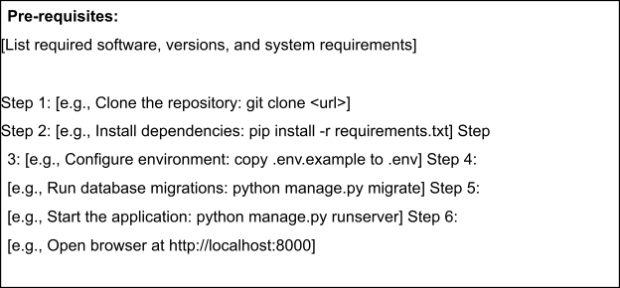

Step 5: Known Issues / Limitations

S.No | Known Issue / Limitation | Workaround / Status
1 | AI image/story generation can take time because it depends on external AI model/API processing. | Wait for generation to finish; ensure the required API keys and internet connection are available.
2 | The current version is intended for local deployment and does not include user authentication or a database-backed history. | Run locally and generate/download comics during the session.
3 | No Docker/container configuration or hosted deployment is included in the current submission. | Run the application using the provided Python virtual environment and Uvicorn instructions.

